**Part 1: PySpark**

1. Provide a screenshot to show that you correctly pulled the *image* and that the docker-compose.yaml file is present.

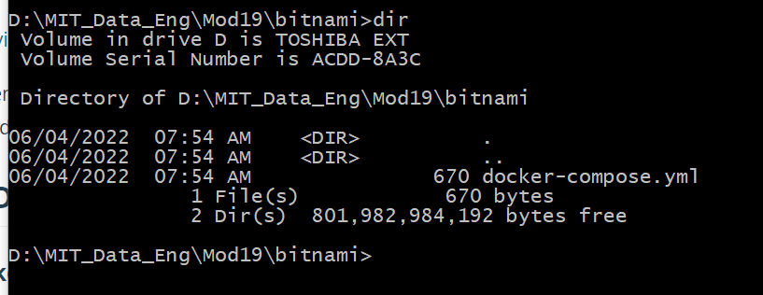

1. Provide a screenshot of your Docker Desktop to show that you correctly pulled the *containers.*

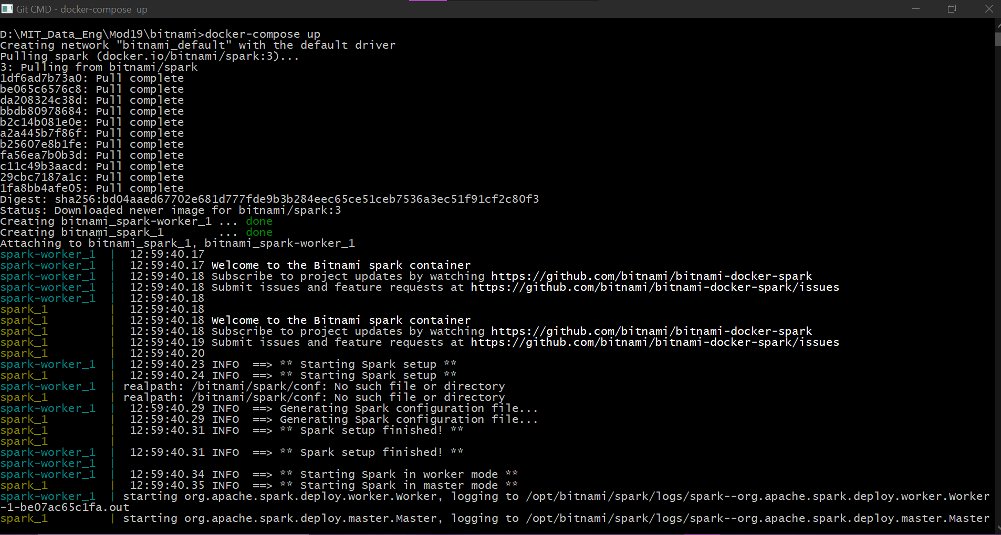

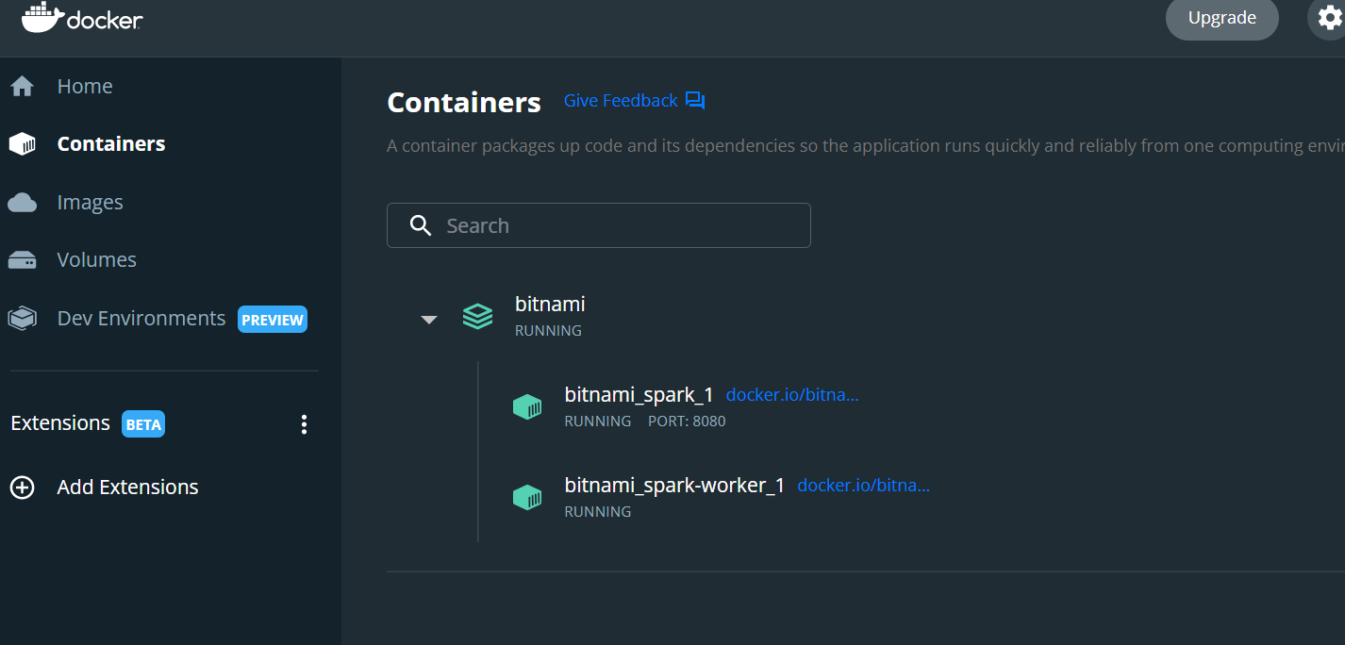

1. Provide a screenshot to show that you successfully copied the departuredelays.csv file to the bitnami_spark_1 *container*.



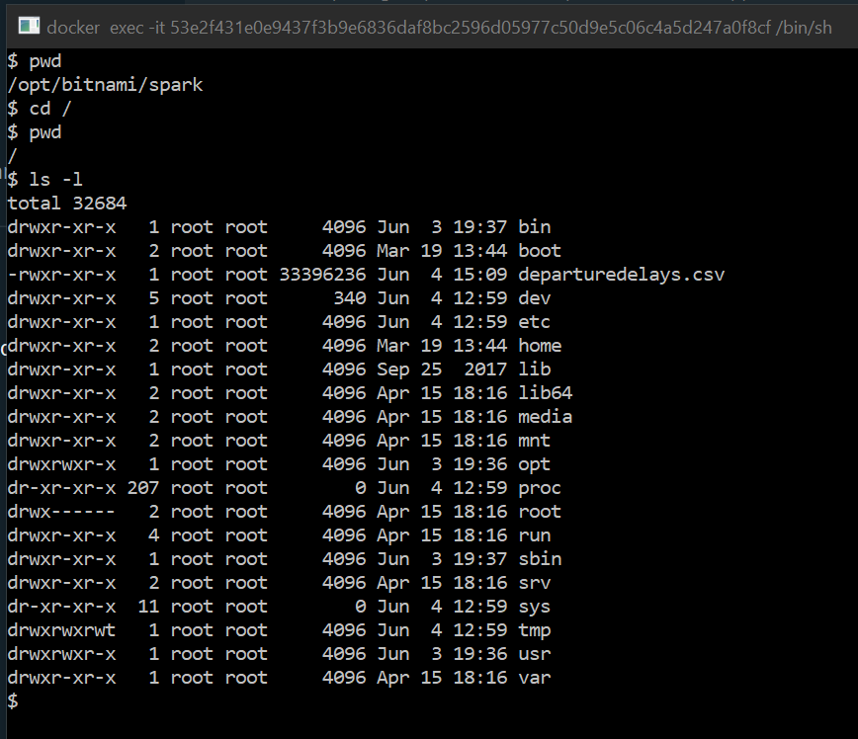

1. Provide a screenshot to show that you successfully opened PySpark.

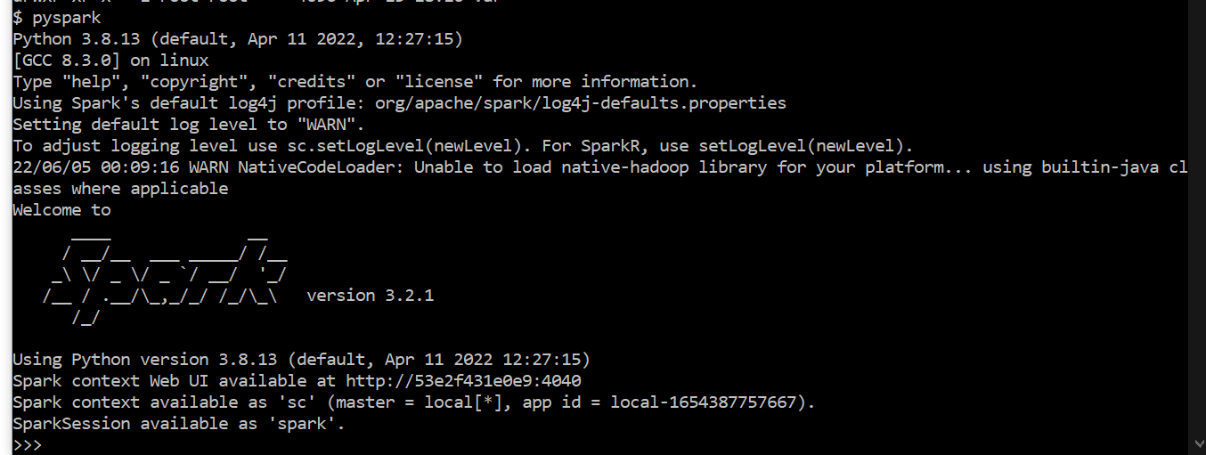

1. Provide a screenshot to show that you successfully started a PySpark session.

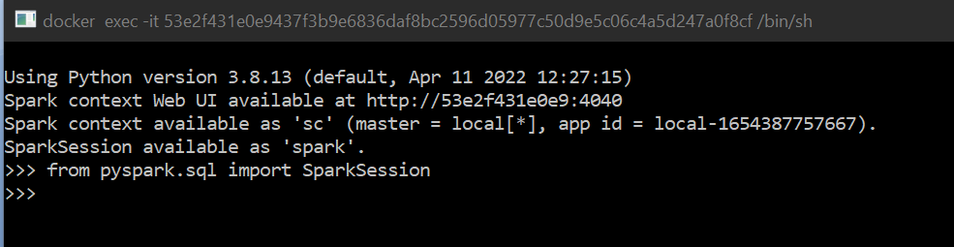

1. Provide a screenshot to show that you successfully defined the spark PySpark session.

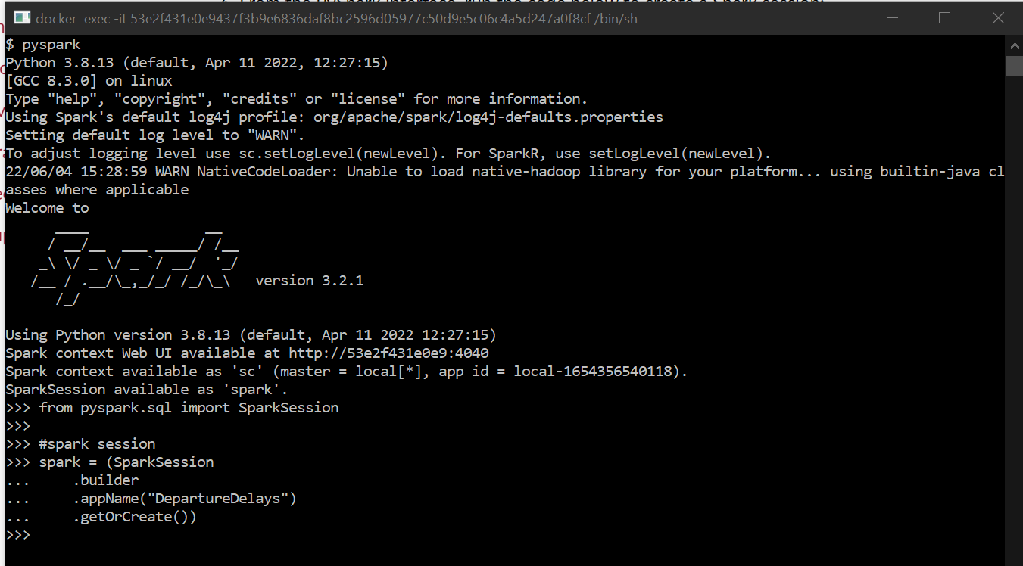

1. Provide a screenshot to show that you successfully defined the assignment19_3_data variable.

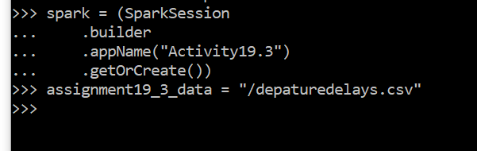

1. Provide a screenshot to show that you successfully defined the df*dataframe* that contains all of the entries in the departuredelays.csv file.

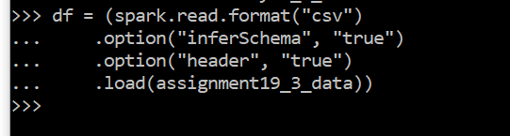

1. Provide a screenshot to show that you successfully created a view of the assignment19_3_table *dataframe*.

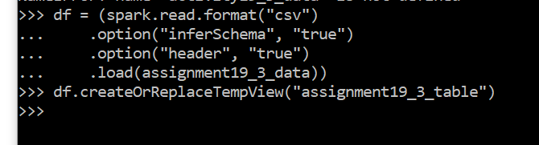

1. Provide a screenshot to show that you selected the correct entries from your data. Your data should display the first 15 flights from PHL to DFW that had a delay of greater than 150 minutes.

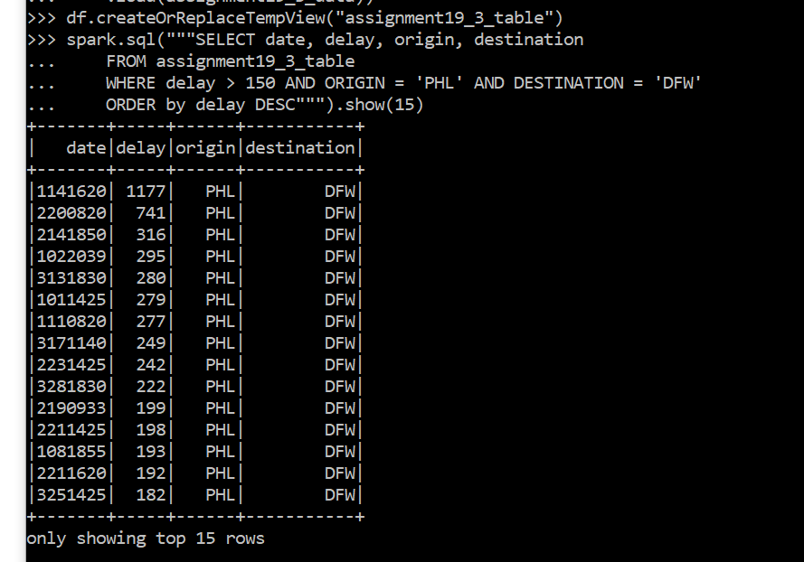

1. Provide a screenshot to show that you selected the correct entries from your data. Your data should display the first 10 flights that have a distance of less than 200 miles and the resulting table should contain all of the columns in the original dataset.

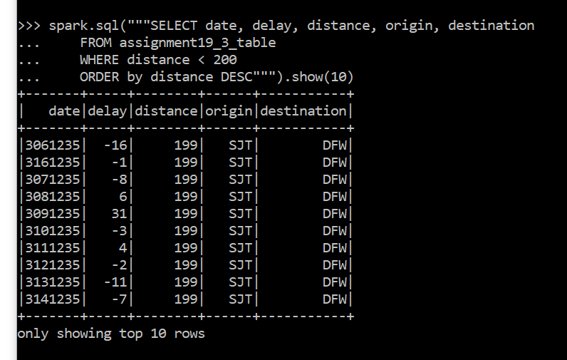

1. Provide a screenshot to show that you selected the correct entries from your data. Your data should display the first 10 flights that have a distance greater than 600 miles and the resulting table should contain all of the columns in the original dataset.

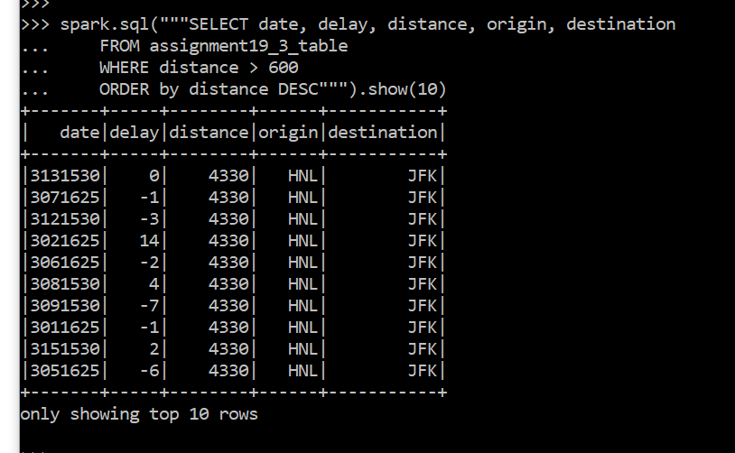

**Part 2: Airflow**

1. Provide a screenshot of your Terminal window response to show that you correctly pulled the Airflow file.

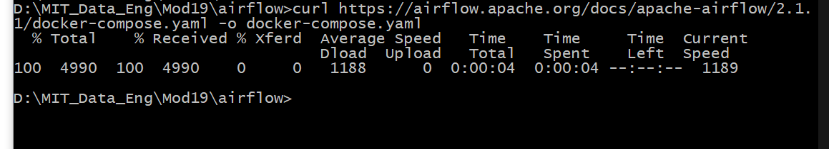

1. Provide a screenshot to show the changed example value ( AIRFLOW__CORE__LOAD_EXAMPLES set to false).

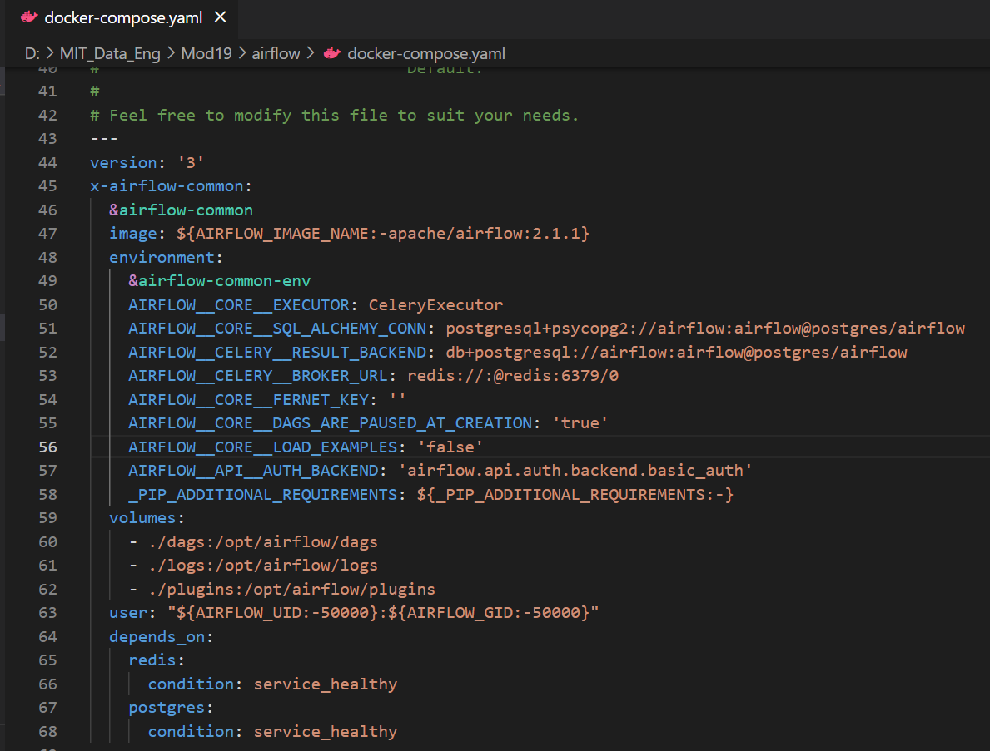

1. Provide a screenshot to show that the Airflow Docker*containers* are running.

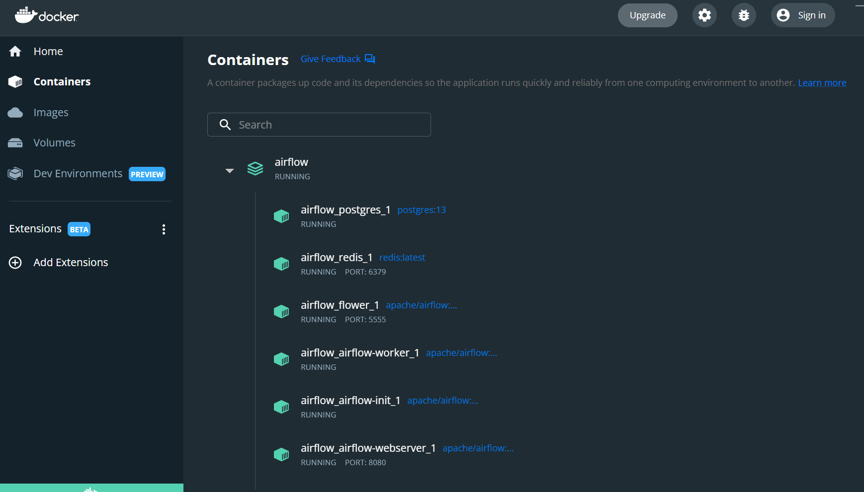

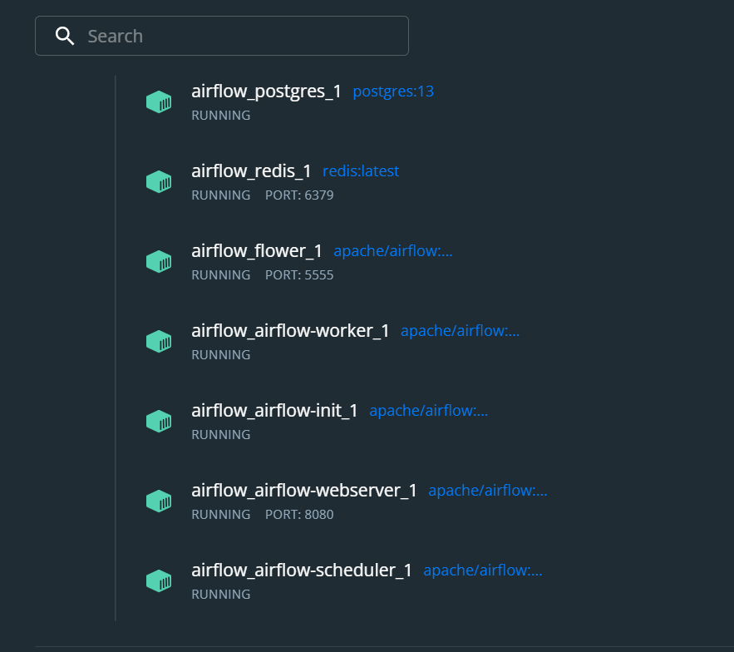

1. Provide a screenshot of your browser window to show that you have successfully logged in to Airflow.

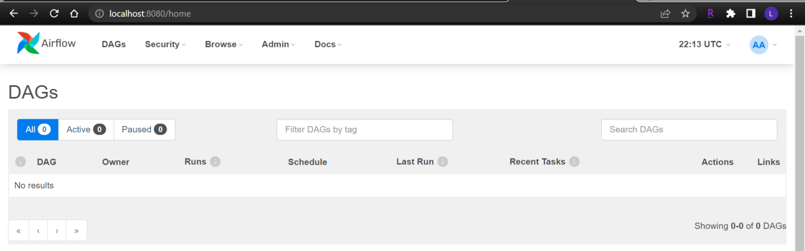

1. Provide a screenshot to show that you created the module19_assignment.py file.

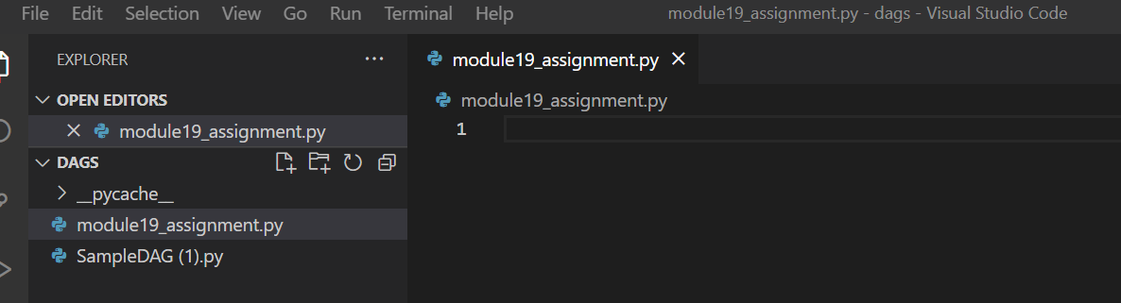

1. Provide a screenshot to show that you correctly imported the required*libraries*.

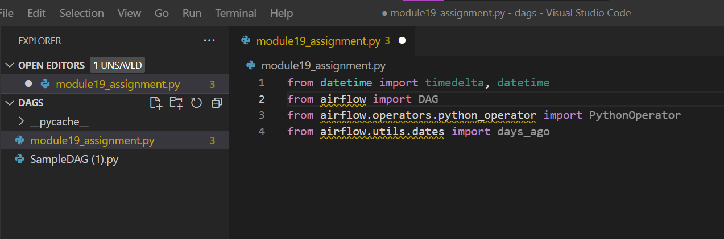

1. Provide a screenshot to show that you set up your DAG correctly, including your last name and email address.

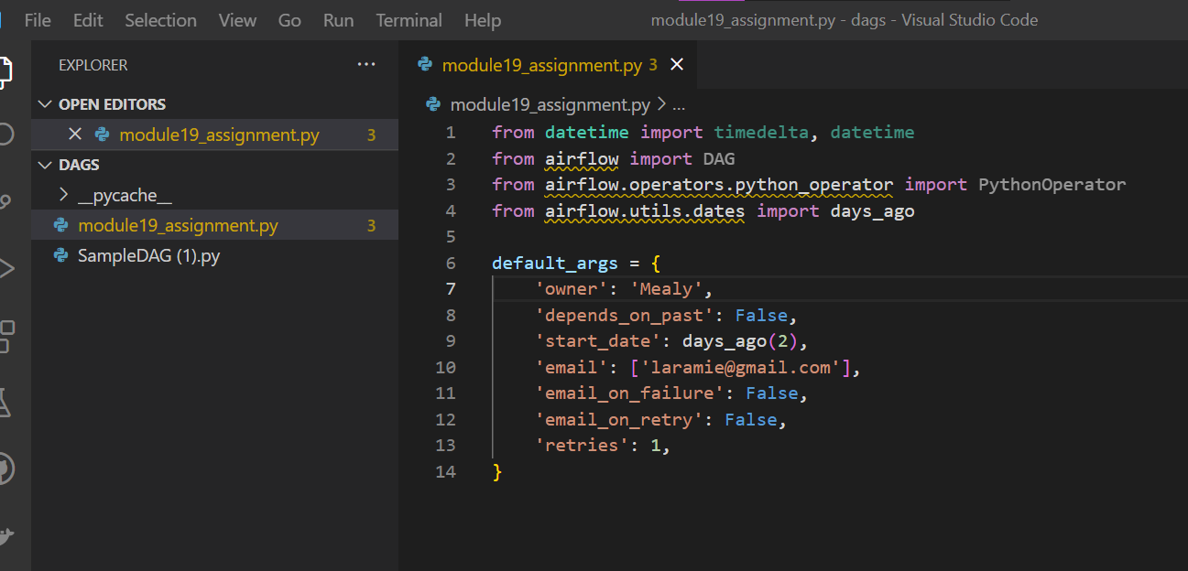

1. Provide a screenshot to show that you defined the square() *function* correctly.

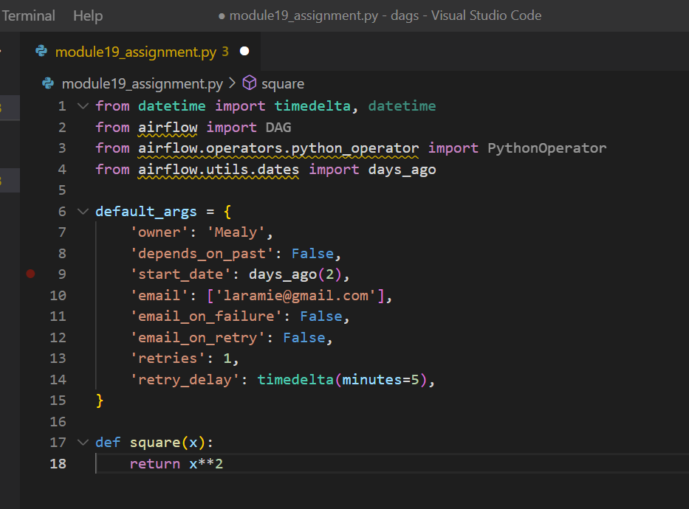

1. Provide a screenshot to show that you correctly defined the DAG object.

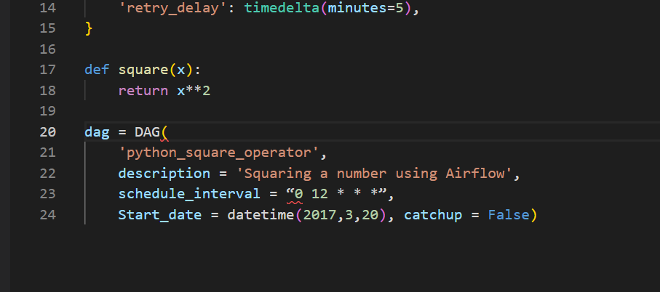

1. Provide a screenshot to show that you defined the DAG*Task* correctly.

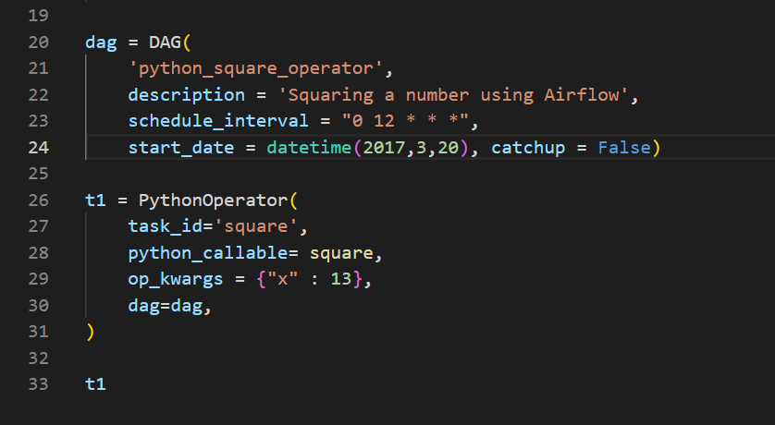

1. Provide a screenshot of the Airflow UI to show that your DAG is configured correctly.

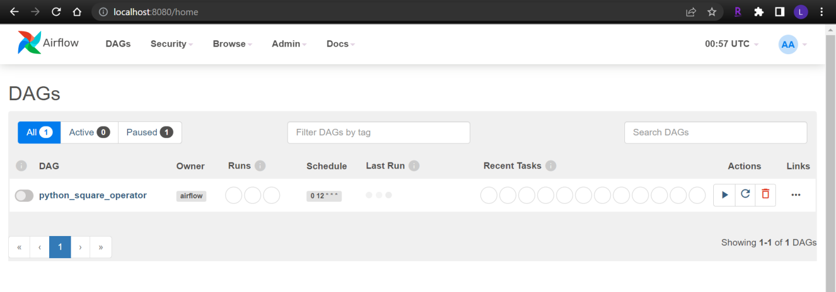

1. Provide a screenshot of the log to show that the DAG ran successfully.

